780 Final Project

Simulating H-H model in PDEs

**Abstract**

For the propagation of an action potential along the squid’s giant axon that is viewed as a cylinder of fixed radius, the membrane potential depends on the spatial variable x and time t in the process of deriving Hodgkin-Huxley model. In the Hodgkin-Huxley model, the separation of the ionic currents and how conductance depends on voltage have been applied with two experimental methods. The first method called voltage clamp allows the membrane potential at a constant or holding level VC. The voltage clamp is the process by infusing current to equal axon and flowing through the voltage-gated channels. The second method called space clamp permits the total current created by inserting a highly conductive axial wire into the fiber. Here, we decide to derive Hodgkin-Huxley model in voltage clamp.

**Introduction**

In the class, we’ve learned full Hodgkin-Huxley model to estimate the current by applying Cable Equation.

**Methods**

1) Ohm’s Law

In the circuit theory, the equation for charge q across a capacitor is q=C*E, where C is the capacitance and E is the voltage across the capacitor. Therefore, the current through the capacitor is given by the time rate of change of the charge, assuming the capacitance C is a constant:

If the voltage E is also space dependent, then we need to write E(z, t) to show that it depends on both a space variable z and the time t. Then the capacitive current will be:

In the Ohm’s law, the voltage is current times resistance; thus, for each ion c, we can write:

Vc = Ic * Rc

where we need to label the voltage, current and resistance with the subscript c because of this ion, which implies

Ic= * Vc = Gc*Ic

where Gc is the reciprocal resistance or conductance of ion c. For Na channel and K channel, the potassium and sodium conductance are nonlinear functions of the membrane voltage V and time t, which indicates the amount of current across the membrane for these ions depends on the voltage differential through membrane that is also time dependent. Generally, the function form for an ion c is

Ic = Gc(V,t)(V(t)-Ec(t))

The driving force, V-Ec, is the difference between the voltage through the membrane and the equilibrium value for the ion in Ec. Note, the ion battery voltage Ec itself might also change in time (for example, extracellular potassium concentration changes over time ). Hence, the driving force is time dependent. The conductance is modeled as the product of a activation, m, and an inactivation, h, term that are essentially sigmoid nonlinearities. The activation and inactivation are functions of V and t also. The conductance is assumed to have the form:

Gc(V,t)=G0mp(V,t)hq(V,t)

where appropriate powers of p and q are found to match known data for a given ion conductance. We model the leakage current, IL, as

IL=gL(V(t)-EL)

where the leakage battery voltage, EL, and the conductance gL are constants that are data driven. Hence, in terms of current densities, letting gK, gNa and gL respectively denote the ion conductance per length, our full model would be

KK=gK(V-EK)

KNa=gNa(V-ENa)

KL=gL(V-EL)

We know the membrane voltage satisfies:

We can rewrite:

where ri is the resistance of the inner fluid of the cable; r0 is the resistance of the outer fluid surrounding the cable; Ke is the value of the externally applied current per length density.

A dynamical electrical circuit

The standard dynamical system for describing a neuron as a spatially iso-potential cell with constant membrane potential V is based upon conservation of electric charge, so that

C

Where C is the cell capacitance, the applied current and represents the sum of individual ionic currents:

In the Hodgkin-Huxley model the membrane current arises mainly through the conduction of sodium and potassium ions through voltage dependent channels in the membrane. The contribution from other ionic currents is assumed to obey Ohm’s law (and is called the leak current). The gK, gNa and gL are conductance (conductance=1/resistance).

**Results**

=10 with noise =10 without noise

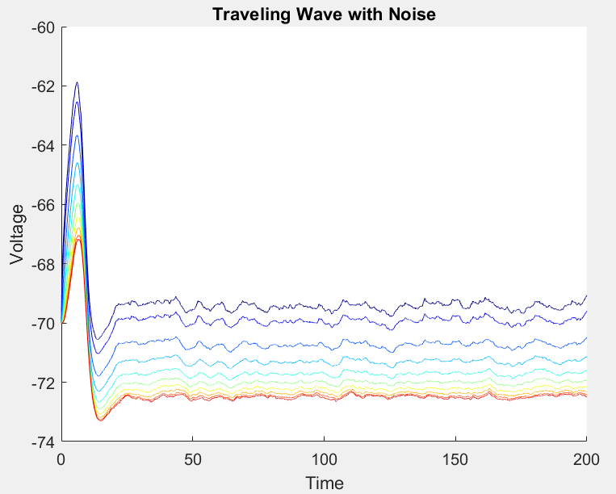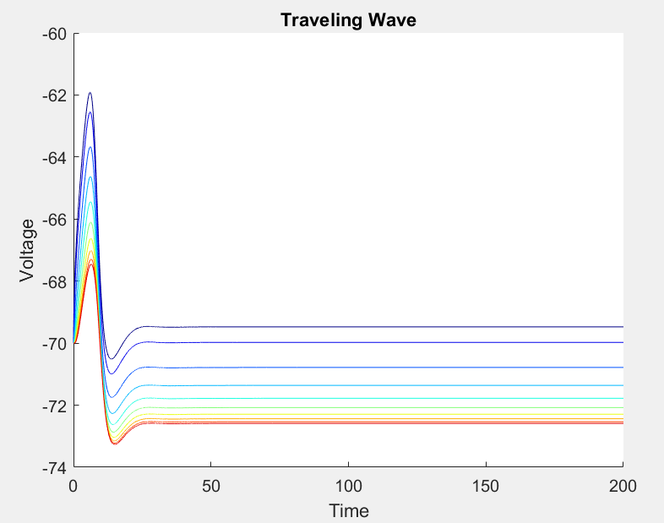

=20 with noise =20 without noise

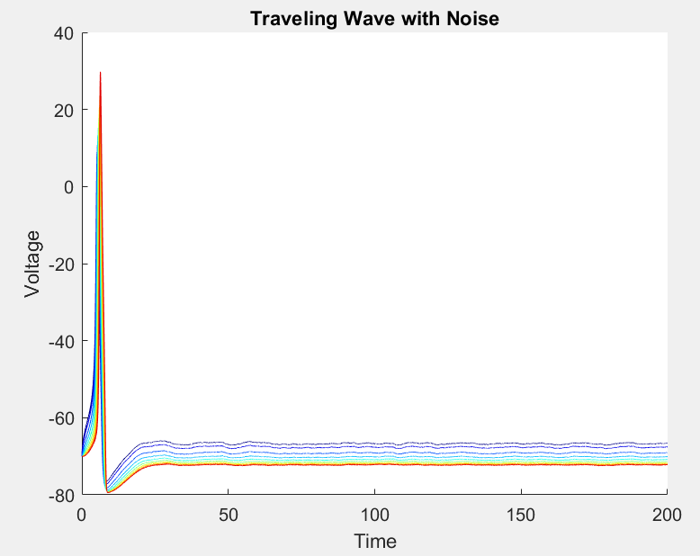 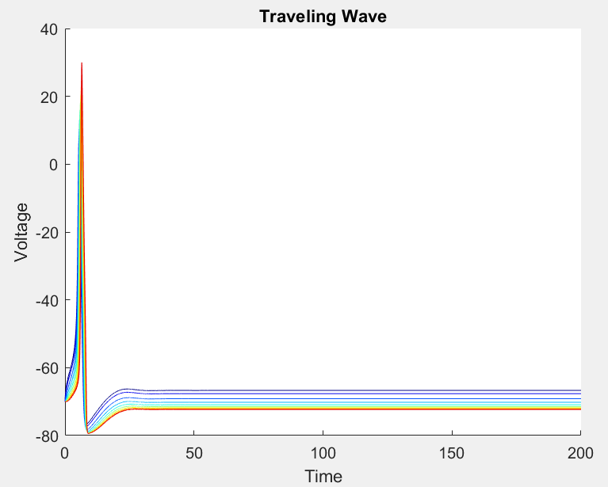

=40 with noise =40 without noise

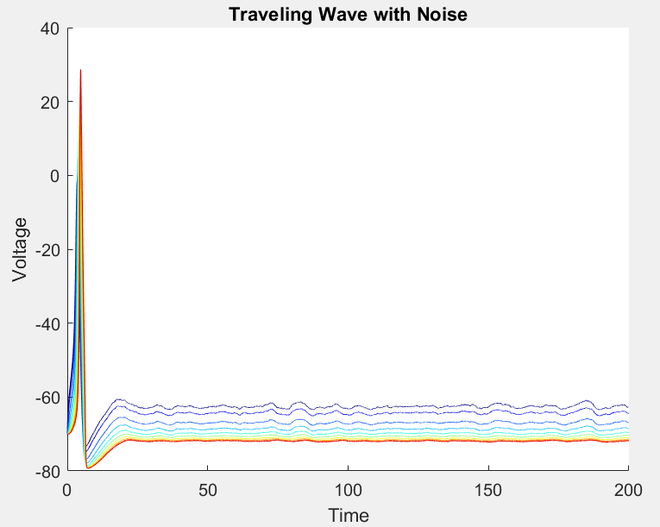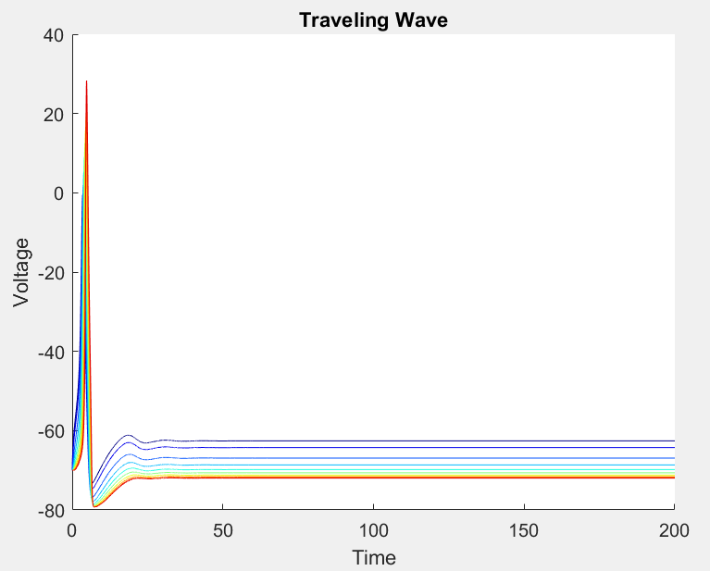

=60 with noise =60 without noise

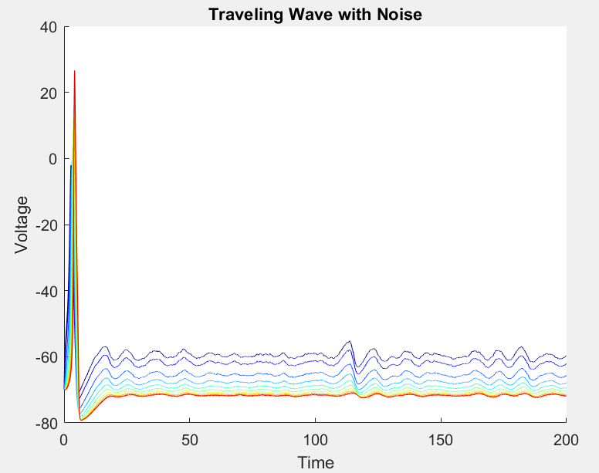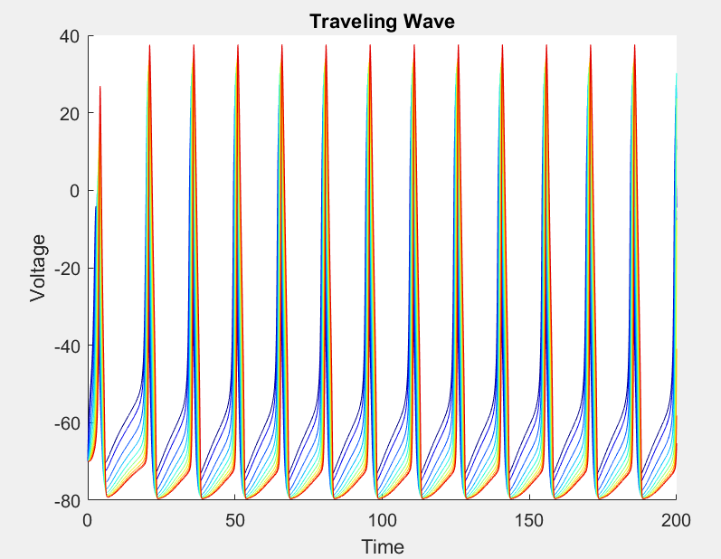

=100 with noise =100 without noise

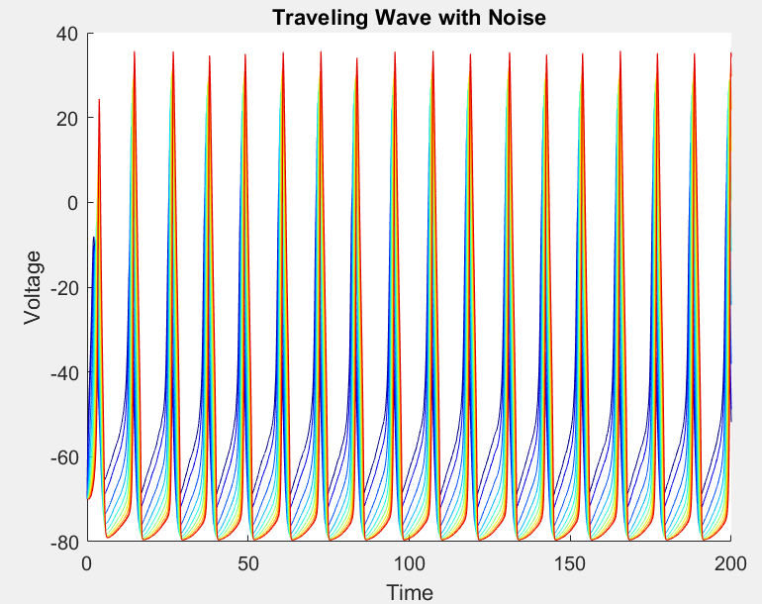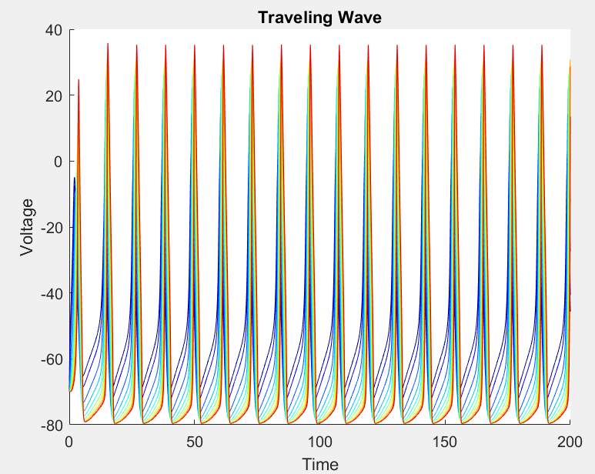

The parameters in conductance-based models are determined from empirical fits to voltage-clamp experimental data, assuming that the different currents can be adequately separated using pharmacological manipulations and voltage-clamp protocols.

When =60 =20

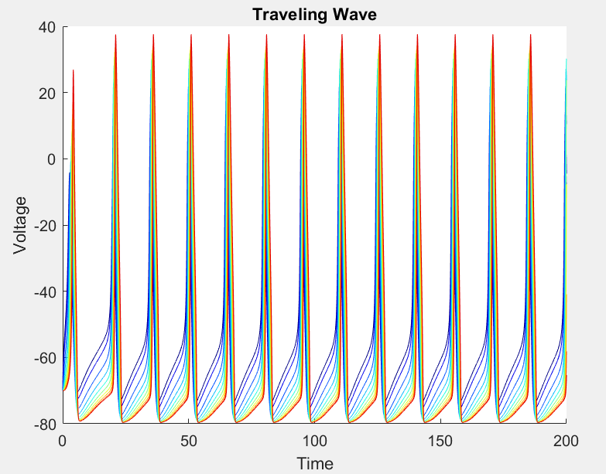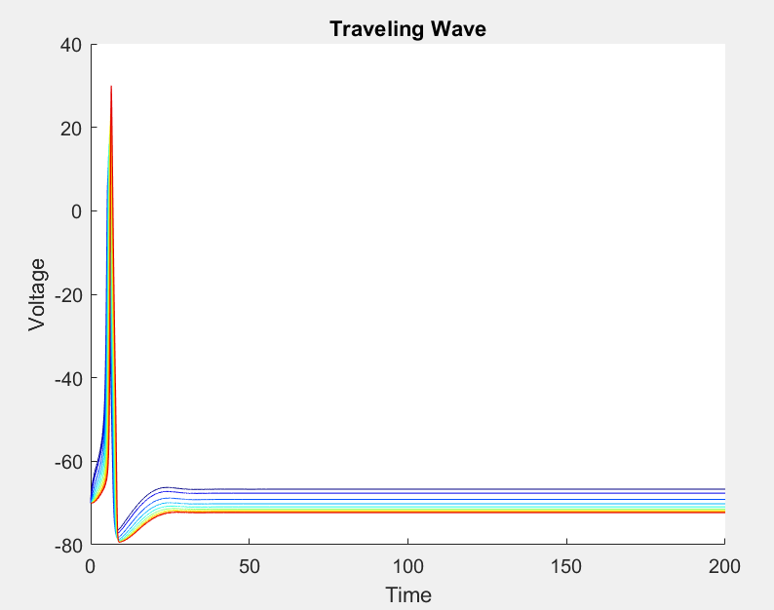

An example of a periodic spike train that can be generated by the Hodgkin-Huxley model under constant current injection. As the  increases, we will get more spikes.

In summary, the basic assumptions in all conductance-based models are: the different ion channels in the cell membrane are independent from each other, activation and inactivation gating variables are voltage-dependent and independent of each other for a given ion channel type, each gating variable follows first-order kinetics, and the model cell compartment is iso-potential.

10,20,40,60, 100 figure out why by changing

CM dV/dt=-gNam3h(V-ENa)-gKn4(V-EK)-gL(V-EL)

dn/dt=φ[αn(V)(1-n)-βn(V)n]

dm/dt=φ[αm(V)(1-m)-βm(V)m]

dh/dt=φ[αh(V)(1-h)-βh(V)h]

When the applied current is below some threshold, the membrane potential returns quickly to the rest; when the current is above some threshold, there is an action potential. If the applied current is sufficiently large and held for a sufficiently long time, then the model generates a periodic response.

**Results**

Simulating Hodgkin-Huxley model in h variable

N=500, plot( t_vec, frac_open), N=5000

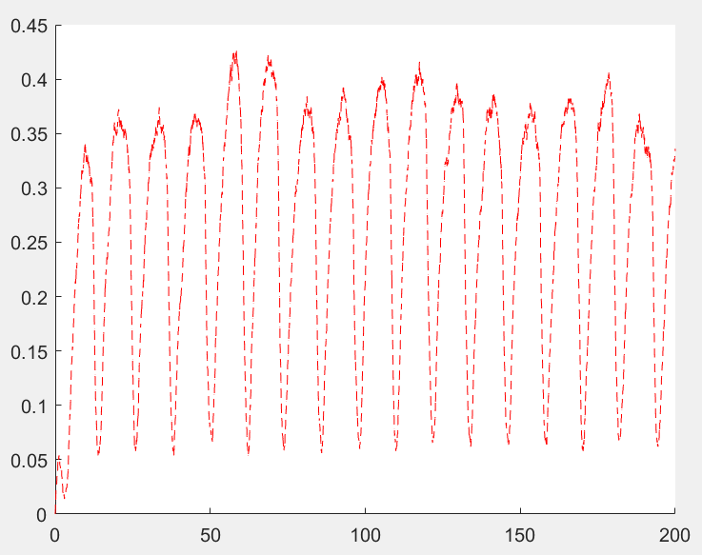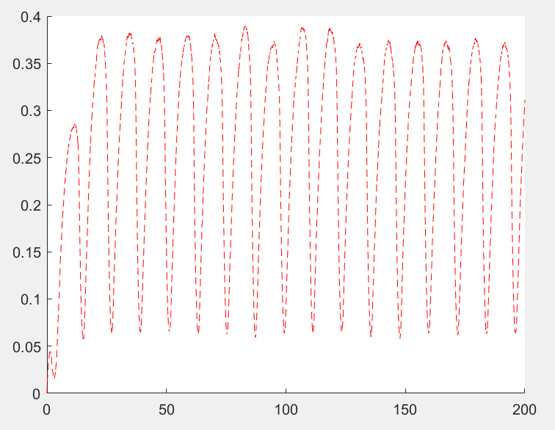

Plot t & v, I_app=20, N=500 & I_app=200

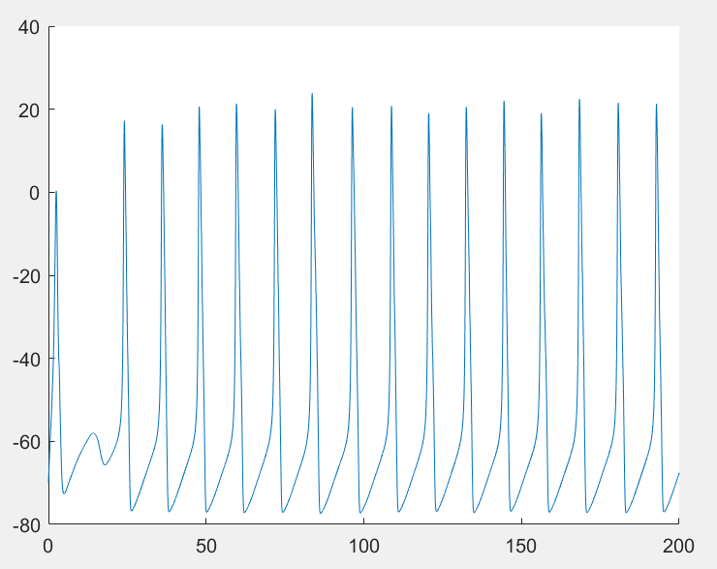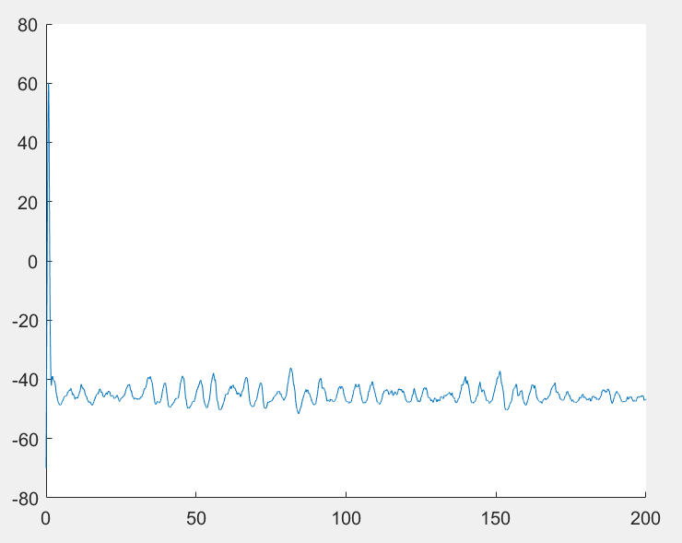

Simulating m variable

I=20, N=500 & I=200, N=500

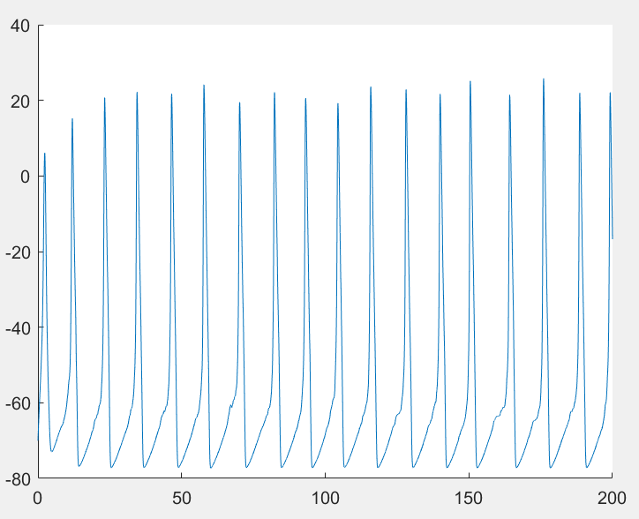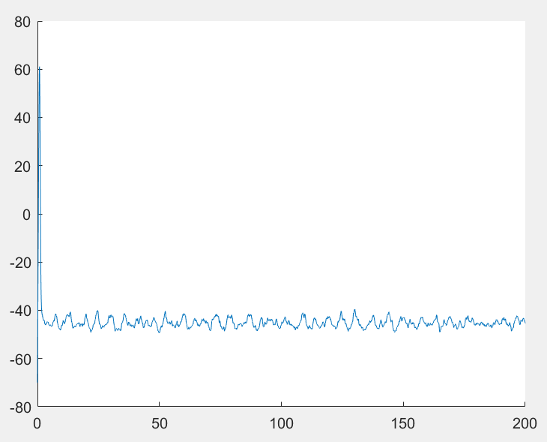

I=20, N=500, t & frac_open; I=20, N=5000, t & frac_open

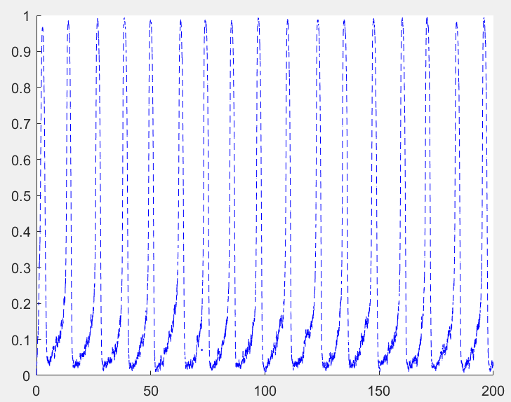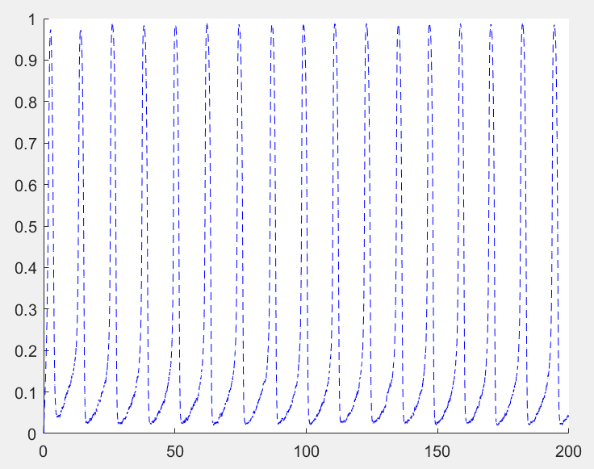

Simulating n variable in H-H model

t & frac_open, I=20, N=500; I=20, N=5000

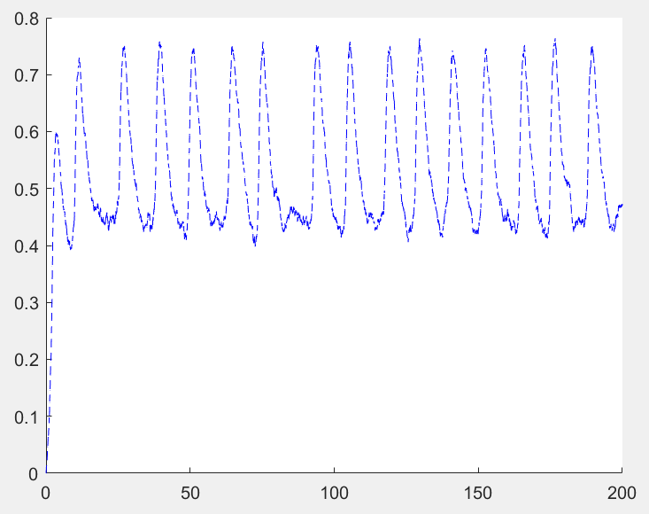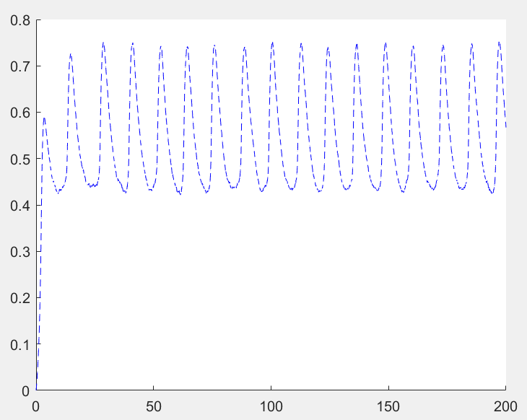

t & v, I=20, N=500; I=200, N=500

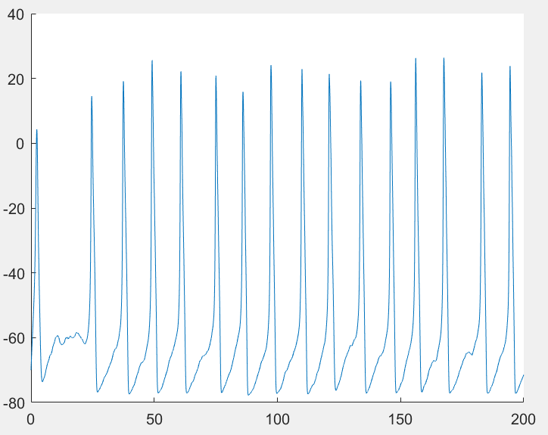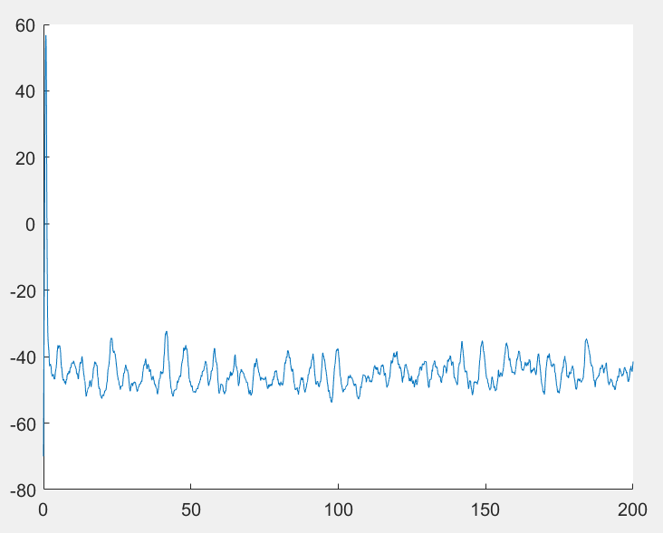

Simulating H-H in PDEs without noise

T=200; T=500

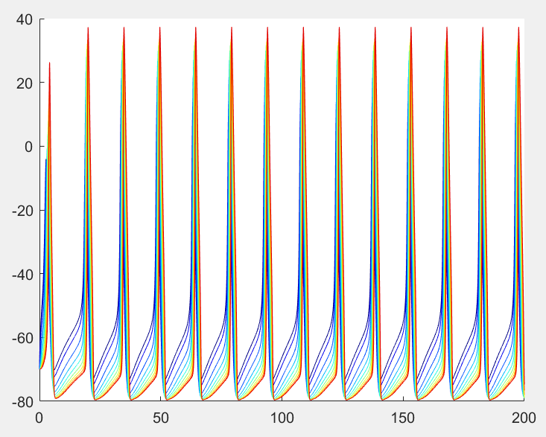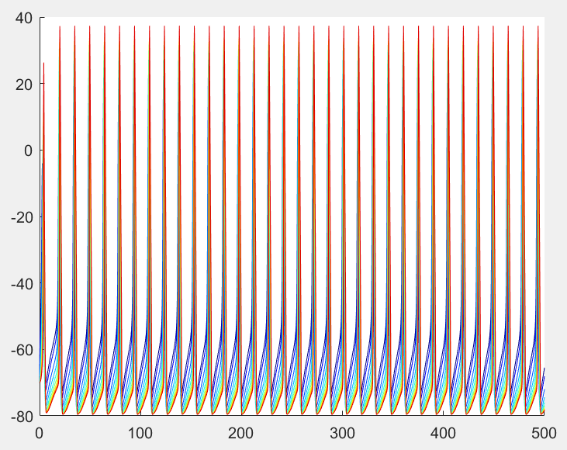

Simulating H-H h variable in PDEs with noise

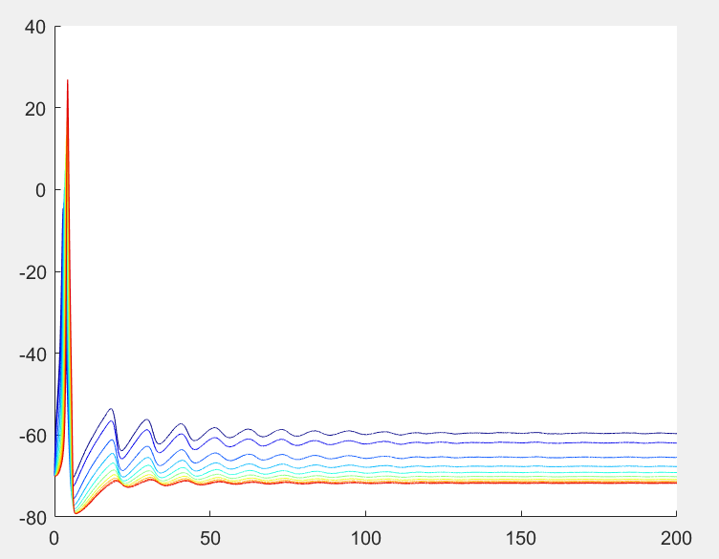

Simulating H-H m variable with noise

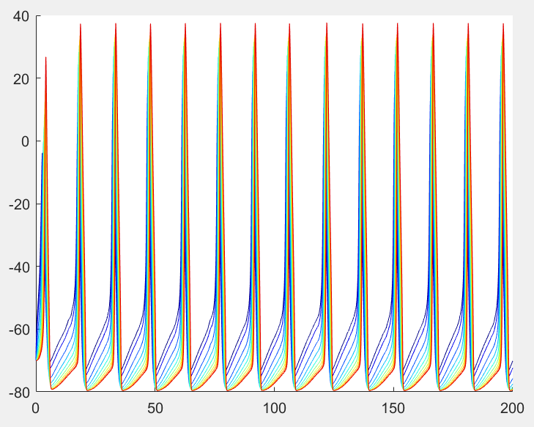

Simulating H-H n variable with noise

